Westwater Technical Brief: PFAS Filter Literature Review
September 24, 2019

Literature were reviewed to evaluate residential PFAS filtration technology effectiveness by commercially-available technologies and also to determine interference by natural water constituents. This brief compares the three main proven and commercially-available technologies: Granular Activated Carbon (GAC), Anion Exchange (AIX), and Membrane Filtration (NF/RO). This brief also provides non-PFAS general water quality parameters needed to inform filter technology selection. The PFAS removal effectiveness of the main different filter technologies are summarized by Dickenson & Higgins in Figure 4-1 (2016). A summary figure is shown on page 2 of this brief.

Granular Activated Carbon (GAC)
GAC filters can remove PFAS compounds however breakthrough of shorter chain compounds tends to occur earlier than longer-chain compounds. The effectiveness of GAC in removing PFAS compounds can be negatively impacted by the presence of Natural Organic Matter (NOM, or “Dissolved Organic Carbon”) (Yong, 2007). GAC has also been shown to be less effective in removing PFOA and shorter chain PFAS compounds due to adsorption competition from Long-Chain PFAS compounds and/or NOMs. (Dickenson & Higgins, 2016; Ross et al., 2018). NOM in creek water at a concentration of 1.7 mg/L were shown to significantly decrease the ability of GAC to remove all length PFAS compounds (Yong, 2007). Organic carbon fouling of the GAC was found to reduce adsorption of PFAS compounds significantly as well (Yong, 2007). While GAC is generally ineffective at softening water, inorganic matter typical of hard water has been known to accumulate on GAC surfaces, resulting in a reduced adsorption capacity for PFAS removal and shortened effective life of the GAC filter (Lambert, San Miguel, & Graham, 2002).

Anion Exchange (AIX)
Similar to GAC, AIX has been shown to be more effective at removing long-chain PFAS compounds than short-chain PFAS compounds (Dickenson & Higgins, 2016). Unlike GAC, however, AIX resins have been shown to be more effective in natural waters than in a laboratory setting, suggesting that the interactions between NOMs, PFAS, and the AIX resin may increase the effectiveness of PFAS removal using AIX (Dickenson & Higgins, 2016). Because AIX is currently used in the removal of sulfate, chromate, nitrate, chloride, and perchlorate, there is concern for sorption competition if these contaminants are also present in the water being treated (Ross et al., 2018). AIX treatment can also be negatively affected by abnormally basic or acidic water (Rahman, Peldszus, & Anderson, 2014). AIX is often used to soften water, meaning hard water can impact the effectiveness and longevity of AIX resins due to sorption competition with PFAS compounds, especially with those of similar molecular weights (Rahman et al., 2014).

Membrane Filtration – Nanofiltration (NF) and Reverse Osmosis (RO)
RO and NF treatments are effective at removing PFAS compounds of all lengths (Dickenson & Higgins, 2016). NF and RO membranes have extremely small pores, causing them to be more susceptible to fouling and deterioration from suspended solids and water chemistry, including salinity and pH. Hard water can also cause scale on RO membranes. Because of this, water with high levels of iron, magnesium, and calcium should be pretreated before passing through the RO system to preserve the membrane for PFAS removal (Jiang, Li, & Ladewig, 2017). Despite these concerns, some studies have shown substantial removal of PFAS by fouled membranes, indicating that these high-pressure membrane technologies could be a resilient PFAS filter (Rahman et al., 2014). NF and RO high-pressure membrane technologies can also be used together to increase the rate of PFAS rejection (Kucharzyk, Darlington, Benotti, Deeb, & Hawley, 2017).

The operating requirements GAC, AIX, and RO systems indicate sampling for alkalinity, hardness, iron, NOM, and Total Dissolved Solids (TDS) will help determine filter suitability and compared to vendor specifications. TDS will serve as an aggregate for calcium, magnesium, and other salts that may foul filters.

According to literature reviewed RO filtration appears to be the most robust of the three technologies reviewed with respect interference by naturally-occurring groundwater constituents and is also capable of removing short- and long-chain PFAS compounds. Westwater makes no warranties or guarantees regarding the effectiveness of these filter technologies.

References:
Dickenson, E., & Higgins, C. (2016). Treatment Mitigation Strategies for Poly- and Perfluorinated Chemicals. Retrieved from http://www.waterrf.org/PublicReportLibrary/4322.pdf
Jiang, S., Li, Y., & Ladewig, B. P. (2017). A review of reverse osmosis membrane fouling and control strategies. Science of the Total Environment, 595, 567–583. https://doi.org/10.1016/j.scitotenv.2017.03.235
Kucharzyk, K. H., Darlington, R., Benotti, M., Deeb, R., & Hawley, E. (2017). Novel treatment technologies for PFAS compounds: A critical review. Journal of Environmental Management, 204, 757–764. https://doi.org/10.1016/j.jenvman.2017.08.016
Lambert, S. D., San Miguel, G., & Graham, N. J. D. (2002). Deleterious effects of inorganic compounds during thermal regeneration of GAC: A review. Journal / American Water Works Association, 94(12), 109–119.
Rahman, M. F., Peldszus, S., & Anderson, W. B. (2014). Behaviour and fate of perfluoroalkyl and polyfluoroalkyl substances (PFASs) in drinking water treatment: A review. Water Research, 50, 318–340. https://doi.org/10.1016/j.watres.2013.10.045
Ross, I., McDonough, J., Miles, J., Storch, P., Thelakkat Kochunarayanan, P., Kalve, E., … Burdick, J. (2018). A review of emerging technologies for remediation of PFASs. Remediation, 28(2), 101–126. https://doi.org/10.1002/rem.21553
Yong, Q. (2007). Study on Treatment Technologies for Perfluorochemicals in Wastewater (Dissertation). Kyoto University Research Information Repository. 1-148. https://doi.org/10.14989/doctor.k13340
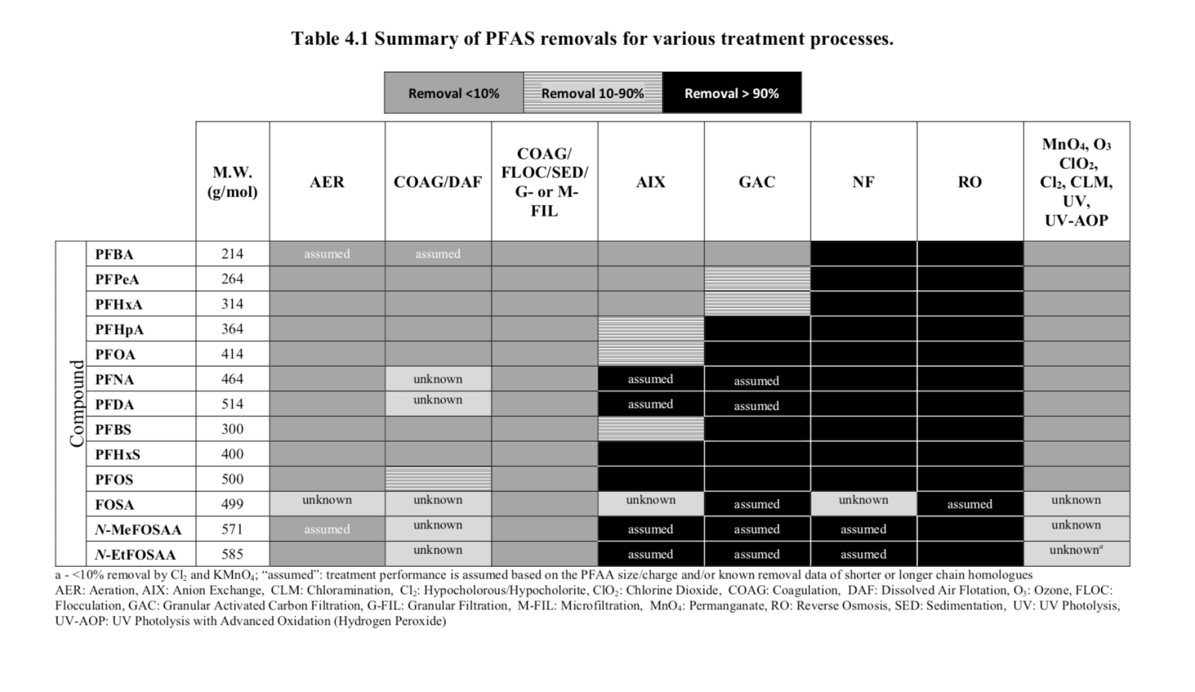
Source: Dickenson & Higgins (2016)

